**Sync Tips and Tricks**

## **Getting Started**

1. Sign-up with organization email at sync.com
2. Install the desktop file/folder structure

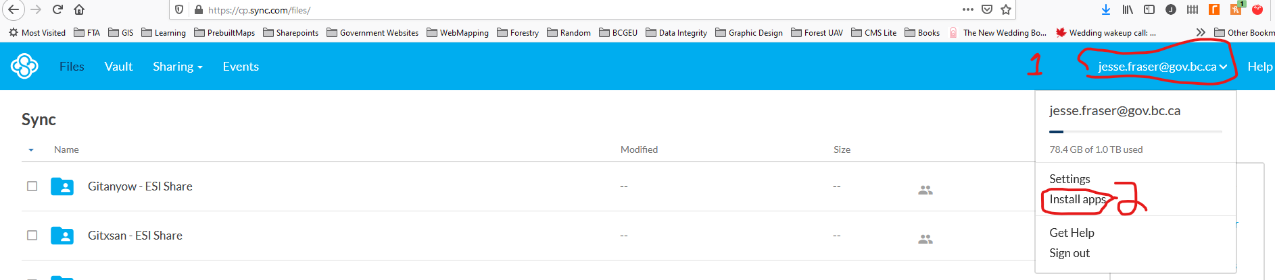

Include screenshot of the strange issue when installing

* 1. Installation will stall at a point in terms of setting up proxy servers to remedy.
     1. Click the configure button
     2. Change the proxy to none and click apply
     3. Change the proxy back to automatic click apply, and then click done (or okay)
  2. Get an individual to invite you to “share folders”
  3. You will receive an email inviting you to the share folder. Click the join share.
  4. Make sure that the 3rd party SSL Certificate box is checked. Graphical user interface, text, application

     Description automatically generated
     1. Open your preferences by:
        1. Clicking the up arrow in your windows tray
        2. Click the Sync App
        3. Click the Gears
        4. Click the Preferences

* + 1. Select the Network tab and turn on the checkmark for the “Allow third-party SSL certificates”

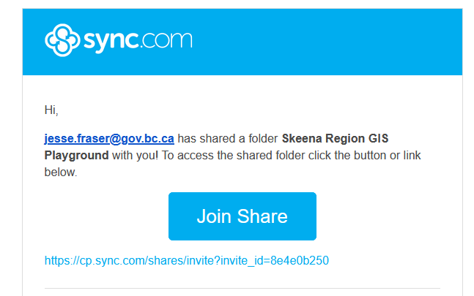

* 1. Keep the folder name as it is (You can change it if you want, but others will see a different name than you). You can change your display name if you would like. Click the “Join Share” button

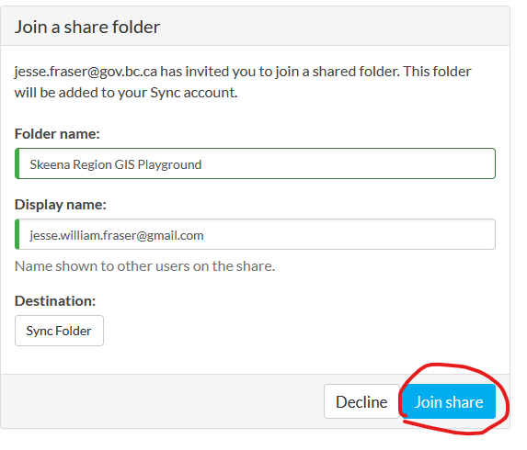

## **Inviting a use to a Share Folder**

1. Drive to the Share Folder (share folders have a little person icon inside the folder icon ) in the Sync website.
2. Click the “Manage share folder” button in the top right

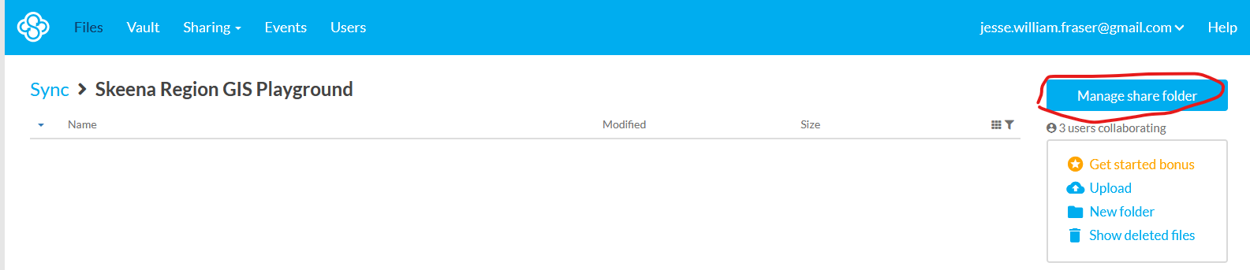

1. In the bottom right click the “+ Add User” button (if you do not see the button you do not have the capacity to invite. In this area you can see the other users in the folder their status (Active, Quit, Waiting Signup) 1and everyone’s permissions under the status column

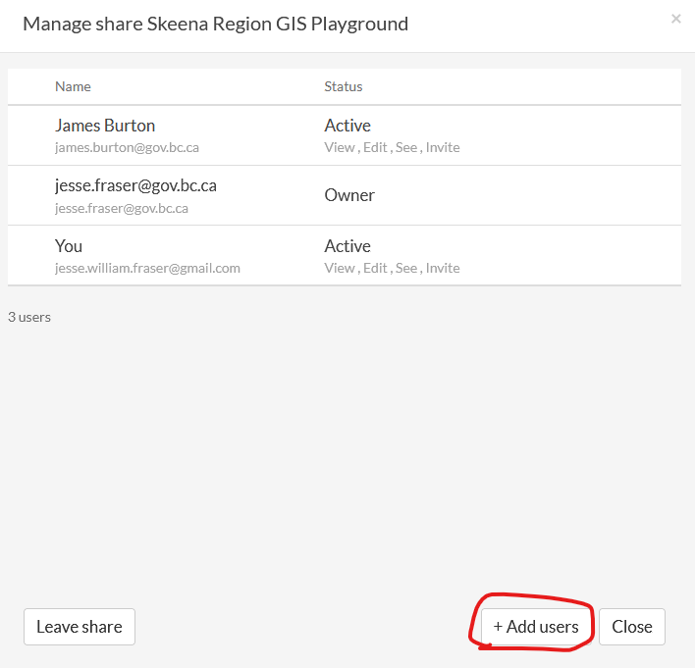

1. Enter the user’s email, and then click the **+** button followed by the “Add users” button.

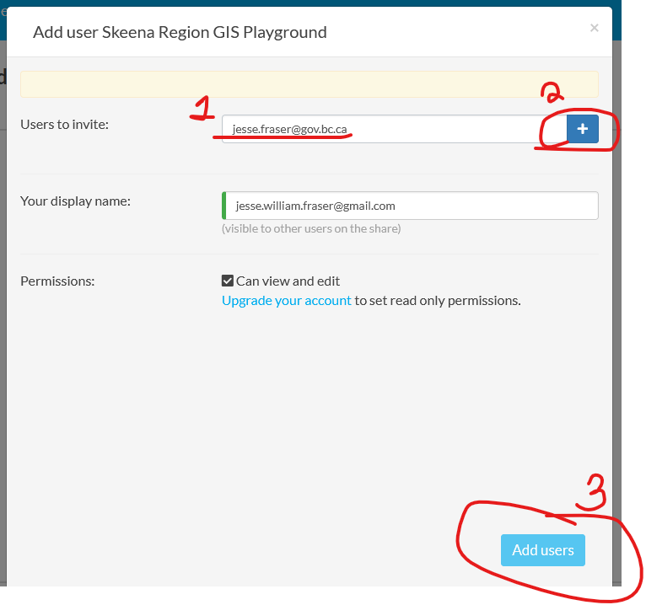

## **Firewalls, and Virus Protection Issues**

## **Tips and Tricks**

This section takes largely from the Sync.com help - <https://www.sync.com/help>.

For desktop application help - <https://www.sync.com/help/the-sync-desktop-application/>

### Is the Sync App working?

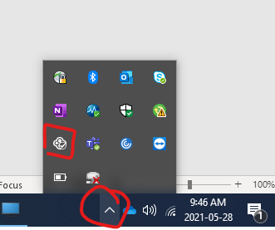

The app will display a status icon in the Windows system tray or Mac menu bar that shows overall syncing status.

**Status icons:**

The Sync status icon is located in the [Windows system tray](https://www.sync.com/help/the-sync-desktop-application/#syncapp) or the [Mac menu bar](https://www.sync.com/help/the-sync-desktop-application/#syncappmac).

**In sync** – a check mark means all files in your Sync folder have finished syncing (backed up to the cloud) and are up-to-date.



**Indexing** – a syncing icon means that the Sync app is indexing or transferring your files. Indexing means that the app is verifying that your files are in sync. When files are transferring you can view transfer status and speeds by clicking the status icon.



**Paused** – a circle with minus sign means that the Sync app is paused (not running). Click the icon and select **Resume**. If the Sync app keeps pausing contact support.

**Error** – an alert symbol means that Sync is unable to synchronize your files and folders. This can occur if you temporarily lose your network connection, or if you go over quota. If the Sync app is stuck in this state contact support

### Choosing Which Folders to Sync (Saving Space)

1. Click on the up arrow to open the windows tray
2. Click the Sync Icon
3. Click the cog on

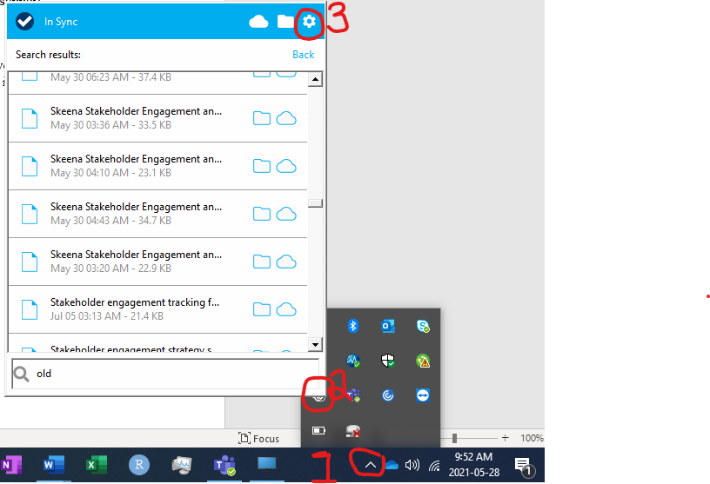

1. In this menu select “preferences” and then the “Advanced” tab. In this tab you can choose which folders will synchronize to your computer.

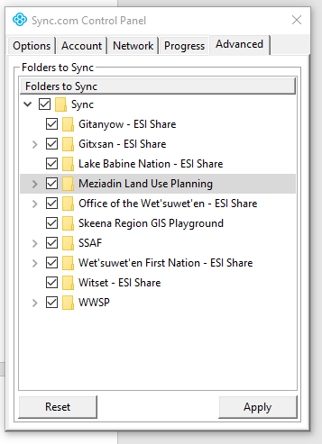

### Editing Documents and Spreadsheets Online

1. Drive to the document through the website (Sync.com), and then select “Edit in Office”

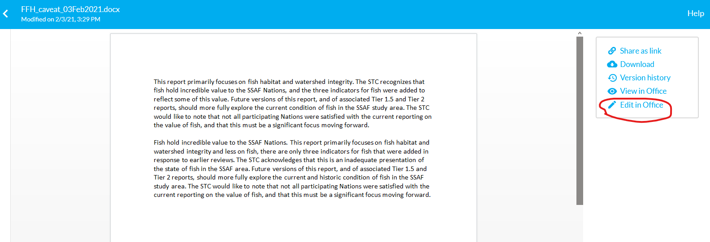

# Best Practices

## Sending files locations in Sync

1. Always send the file path based on the folder structure when sending documents.
   1. For the web panel format it by each folder name you have to click on
   2. For the file/folder structure copy and paste **ONLY** from the share folder, and below.
      1. For example the full file path for this how to is: “C:\Users\jwfraser\Sync\Indigenious Stewardship Forums\SSAF\Data Management\Background Info\How To\Sync\HowToSync”
      2. The correct on to send out is -> “\Data Management\Background Info\How To\Sync\HowToSync”
2. If you have a paid Account send the a link alongside the path.
3. Sending both allows people to either easily access via the link, or go into Sync and edit via the file path.